**Amazon Elastic Container Service (ECS)**, also known as Amazon EC2Container Service.

**AWS ECS**

Amazon elastic container service is a fully managed service which is provided by AWS it is mainly used to deploy containers that are docker based.

It is a managed service that allows users to run Docker-based applications packaged as containers across a cluster of EC2 instances.

The containers will run inside the Amazon elastic cloud (EC2) instance.

How Elastic Container Service Works?

1. **Container:**A container is a package that holds an application and everything dependencies, libraries, etc.) the application requires to run.
2. **Docker:** facilitates and automates the installation and deployment of applications inside Linux containers.
3. **Cluster:**A logic group of EC2 instances running as a single application.
4. **Container Instance:**Each EC2 in an ECS Cluster is called a container instance.

Advantages-

Scalable- ECS automatically scales your applications based on demand, allowing you to easily handle changes in traffic or workload

Integration- ECS integrates with other AWS services such as Amazon ECR, AWS Fargate, Amazon CloudWatch, and AWS IAM.

Secure- ECS provides a secure environment to run your applications, with features such as IAM roles for tasks, VPC isolation, and encryption.

Steps-

In the Elastic Container Service following steps are followed-

Create the cluster by giving the name to the cluster and select AWS Fargate in the infrastructure.

Click on the create to create the cluster.

Once the cluster has been created it shows as below

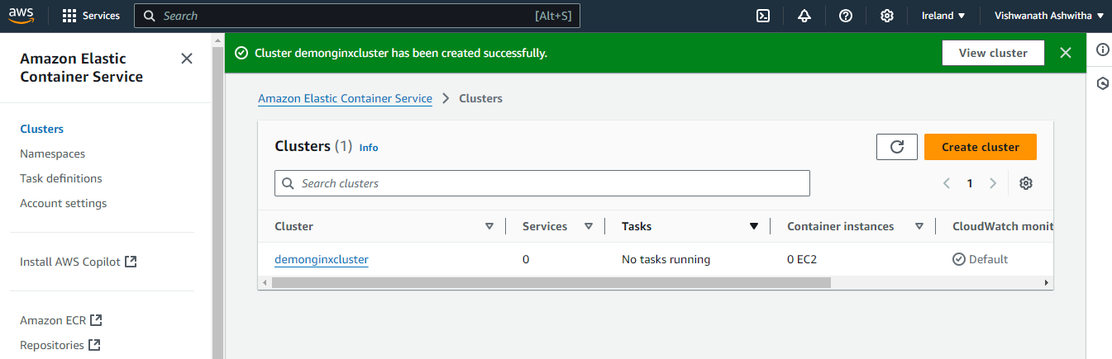

And then, create the task definition

By adding the following task definition can be created- name task definition family; in the infrastructure requirements select AWS Fargate; in the container details name the container, provide the image URL, also the port name

Then click on create, once created displays as shown below

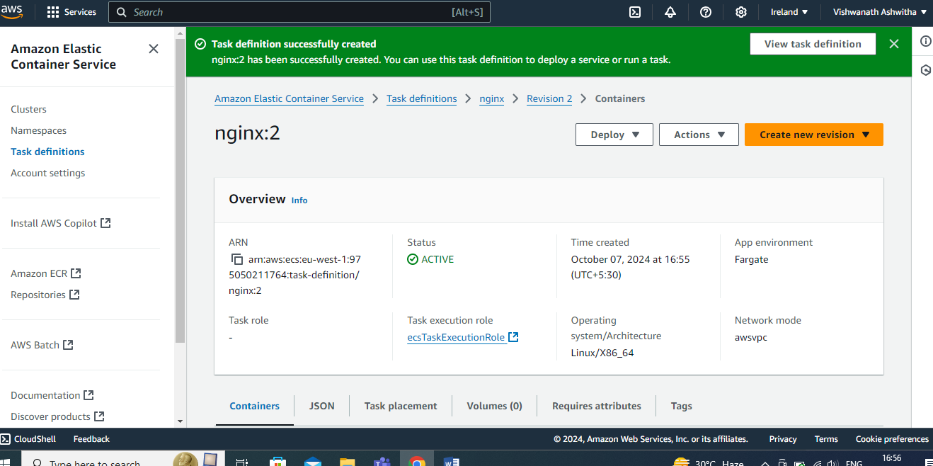

After creating the task definition, in the cluster – tasks option create– click on run new task

Select the launch type in the compute options and select Fargate

Select service in the application type and also select family which is created (task definition family), provide the service name

Also select the desired number of tasks

In the load balancing – select the application load balancer in the load balancer type and provide load balancer name

Then click on create to run task

After creating run task it is shown as below

